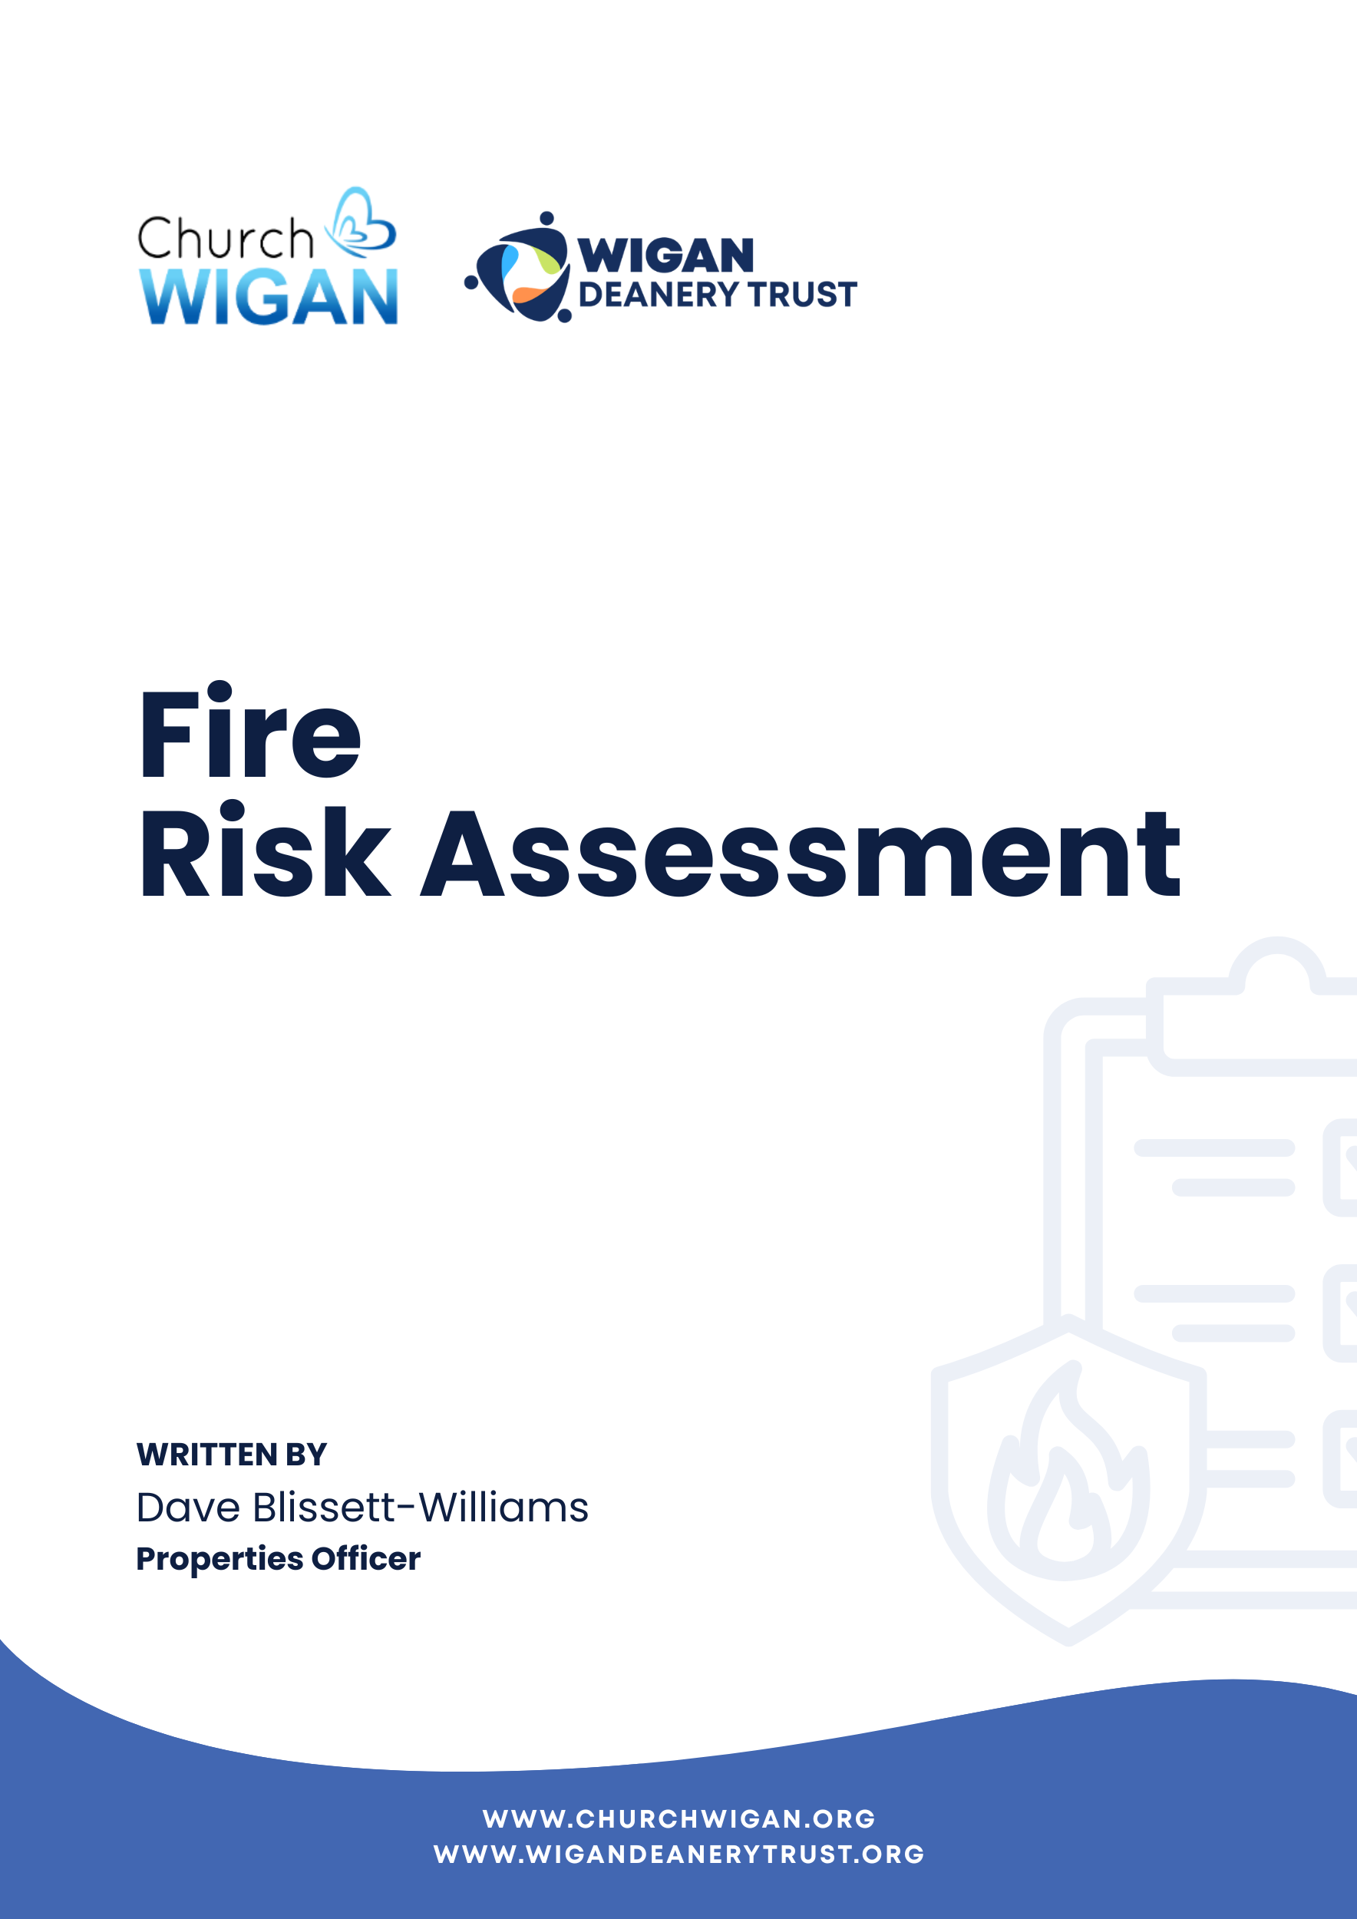

Fire Risk Assessment
How to use this Fire Risk Assessment
The assessment has the following sections which you will need to read and then complete:
Part 1 – Information About Our Church
Part 1 of the assessment is about collecting together all the information you need about your church so that you can perform the Fire Risk Assessment. It is broken down into various sections which are summarised below.
A Our Church Details Basic information about our church location and the person responsible for the Fire Risk Assessment.
B Parochial Church Council Declaration A declaration about the awareness and understanding of the Parochial Church Council (PCC) or other church management committee of the requirements of the Order to be signed by the appropriate person.
C General Information About Our Church Description of the church building and how it is used.
D Potential Fire Hazards at Our Church Details of fire hazards, sources of ignition and their elimination or control.
E Our Fire Protection Arrangements Details of the current arrangements we have in place for fire protection.
F Our Fire Detection, Warning and Extinguisher Equipment Details of the equipment we have in place and its testing and maintenance.
G Our Fire Safety Management Information about our plans should a fire occur.

Part 2 – Our Fire Risk Assessment
Part 2 of the assessment is about the fire risks at our church and how we will go about fulfilling our obligations under the order.
Part 3 – Our Arrangements for Fire Safety at Our Church
Part 3 of the assessment details the measures we have taken to offset the risk of fire at our church.
Part 4 – Our Action Plan to Reduce Fire Risk at Our Church
Part 4 details any gaps in our fire protection arrangements and outlines what we are going to do to address them.
Appendix 1
Examples to help you complete Part 2 – Our Fire Risk Assessment.
Appendix 2
Examples to help you complete Part 3 – Our Arrangements For Fire Safety At Our Church.
Appendix 3
Fire Action Notice A specimen notice that needs to be placed near all exit doors and in separate areas such as vestries, which you will need to complete for your church.
Part 1 – Information About Our Church
A. Our Church Details
Name of church:
St Thomas’s Church Hall
Address:
Warrington Road, Wigan, WN4 9PL

Responsible person:
Employer or other persons having control of the relevant premises e.g. PCC

B. Parochial Church Council Declaration
As a church, we understand that we are required to undertake a Fire Risk Assessment in accordance with the Regulatory Reform (Fire Safety) Order 2005 (in Scotland, fire safety duties are contained in part 3 of The Fire Scotland Act 2005, as amended and The Fire Safety Scotland Regulations 2006) even if we have no employees.
We note that we are required to take such general fire precautions as will ensure, so far as is reasonably practicable, the safety of employees, if we have any, and to take such general fire precautions as may reasonably be required in the circumstances to ensure that the premises are safe for all other visitors to the church including volunteers, members of the congregation, and contractors. Our Fire Risk Assessment and arrangements are therefore directed to the safety of people rather than the protection of the building itself.
We understand the PCC is the responsible person, and we will appoint one or more competent persons as appropriate to assist us in undertaking the preventative and protective measures.
We understand it is the responsibility of the Responsible Person(s) to fully record the following information in the fire risk assessment: -
- All findings from their fire risk assessment regardless of the size or purpose of the premises in full.
- Fire Safety Arrangements that show how you manage fire safety in the building. These can be anything from procedures you need to have written down to polices you have in place.
- Details of the appointed Fire Risk Assessor who undertakes or reviews any or all of the fire risk assessment.
In carrying out our Fire Risk Assessment, we have followed the Government guidance published by the Department for Communities and Local Government (for Scotland – Scottish Government’s Police and Community Safety Directorate, HM Fire Service Inspectorate for Scotland, the Scottish Building Standards Agency and the Health and Safety Executive) and have noted from this document that the action we take should be common sense and in the main, not expensive. We have also noted Appendix C of the guidance for Fire safety risk assessment: small and medium places of assembly which refers to listed and historic buildings and note that we will need to endeavour to strike a balance between ensuring sufficient fire safety measures are in place for the safety of people, yet avoid extensive alterations and helping to maintain the character of the building.

Signed on behalf of the PCC:
Dave Blissett-Williams

Persons appointed to assist the PCC in undertaking fire preventative and protective measures:
Dave Blissett-Williams

Date fire risk assessment was completed:
January 2026

Suggested review date:
January 2027

(The risk assessment needs to be reviewed regularly to keep it up to date, particularly where there is reason to suspect that it is no longer valid, or there has been a significant change in the matters to which it relates).

C. General Information About Our Church
THE BUILDING:
Number of floors:
One – Ground Level.

Floor area (approximate overall size in square metres):
750m2 approximately

Building description:
A new build prefabricated property constructed/completed in 1980s with one ground level floor constructed in brick/wood and felt roof with double glazed windows and doors with a ramp providing access to those with mobility issues.
(Describe what the building comprises noting if there is one main undivided area and then separate parts which can be closed off from the main area which could prevent the spread of a fire, e.g. The main undivided area of the church comprises a lofty nave and chancel with north and south aisles and organ chamber. There are north and south porches and a vestry all of which can be closed off from the main part of the church by substantial oak doors. There is a tower at the west end of the church which is completely separated from the rest of the church and can only be accessed from an external door.)
Basic construction details:
Brick/wood and felt roof.
Use of the church:
Services, Community Events, Food Pantry.
Note the use of the building and how often it is occupied, e.g. The church is used for services twice on a Sunday but otherwise the use is very limited. There is the occasional concert. You should draw a plan of the church which can be used during the risk assessment process and then as a part of your fire safety arrangements documentation. This should be roughly to scale and should identify by name the main parts of the church and note all doors both internal, which separate different parts of the church, and external, which provide means of escape. The plan can be used to note the location of fire extinguishers and other relevant information. You can use a tape measure or rule to measure the building, but an easy way is to pace along the outside walls and note down the distances. A good pace is about 1 metre. There is a blank page at the back of this document for you to draw a plan of your church.

PEOPLE AT RISK:
Occupants:
Approximate average number attending a normal service:
1 – 100

Approximate maximum number attending special services and events such as weddings and at Christmas:
Maximum occupancy of 100

Approximate number of employees and/or volunteers in the church at any one time:
7

OCCUPANTS AT SPECIAL RISK FROM FIRE:
Give details of any persons with disabilities who attend the church who would need help in evacuating the building:
N/A

Give details of any children who attend the church and whether they occupy a different part of the building during services such as a Sunday School in the vestry:
Children would occupy the main part of the building with adults and with supervision.

Give details of the number of persons who occupy remote parts of the building and when:
N/A
(For example, do bell ringers practice when there is no-one else in the church. Does the organist practice alone or does someone undertake maintenance in an enclosed boiler room?)

BACKGROUND INFORMATION:
Previous fire losses:
Detail any fires or related incidents that anyone can remember even if it did not result in an insurance claim.
None.

Other relevant information:
Note any other information which could have a bearing on the risk of fire such as the nature of any nearby or adjoining premises or evidence of arson.
N/A – No history of arson.

D. Potential Fire Hazards at Our Church
Where the answer is NO then some action may be required in order to ensure that your fire safety arrangements are satisfactory. This needs to be noted in the Action Plan at the end of the assessment. If the situation does not apply, enter N/A.
Electrical
Is the fixed electrical system inspected and tested by a competent person at least every five years? Yes
If YES, state the name of the competent person and the date of the last inspection.
Hughes Electrical Services – 03/08/2020 (Overdue) Paula Gillespie aware

Are all portable electrical appliances including those belonging to outside bodies annually tested? (PAT testing) Yes
If YES, state the name of the tester and the date of the last test
Helen Cornthwaite – 30/09/2023 (Overdue) Paula Gillespie aware.

Are any electrical items that fail the testing removed immediately from the church?
Yes
Is the use of trailing leads and multi-point adaptors restricted as far as possible and subject to control?
Yes
Heating
If portable electric heaters including electric fan heaters, and radiant ‘bar’ type fires are used, are they included in the PAT testing programme and are they kept away from combustible materials? Yes
(Remember to check areas that you would not normally visit such as the ringing chamber or clergy vestry.)
If portable LPG (liquid petroleum gas) heaters are used, are they fixed away from combustible materials and are the arrangements for the storage and replacement of spare cylinders satisfactory? N/A
If heating appliances burning coal or other solid fuel, e.g. wood pellets, are used, are arrangements in place to ensure fire cannot spread accidentally? N/A
Are gas boilers subject to an annual maintenance contract with an approved Gas Safe Registered contractor? Yes
If YES, state the name of the contractor and the date of the last inspection.
HeatinGlobal – 24/06/2025

Are oil-fired boilers subject to an annual maintenance contract with an approved OFTEC contractor? N/A
If YES, state the name of the contractor and the date of the last inspection.
N/A

Are oil tanks suitably bunded or double skinned and fitted with a safety cut-off valve? N/A
Do you ensure that all heating appliances are kept clear of combustible materials?
Yes

Arson
Have you considered the risk of arson and malicious attacks?
Yes
Is the storage of combustible materials and flammables such as petrol for mowers kept to a minimum and in a secure place where the risk to people is minimised?
Yes
Have you removed or kept secure anything which could be used by an arsonist such as matches and candles?
Yes
Cooking
If you have a kitchen or servery in the church, are measures in place to prevent fire as a result of cooking?
Yes
If kitchen equipment includes filters or ductwork, are they cleaned regularly? If YES, state how often.
N/A

Are suitable fire extinguishers and a fire blanket located in the cooking area?
Yes
Lightning
If the church has a lightning conductor, is it inspected by a competent, specialist Lightning Engineer at recommended intervals?
N/A
If YES, state the name of the contractor and the date of the last inspection.
N/A

Combustible Materials
Has combustible material been removed from the church as far as possible?
Yes
(Examples of combustible material which can accumulate are hay and straw used in Christmas cribs, articles collected for jumble sales but never sold, wastepaper collected for recycling and old Christmas trees.)
Are all exits and escape routes kept clear of combustible materials?
Yes
Contractors and Building Works
Are outside contractors subject to control when working in the church and are they required to use a ‘hot work’ permit system when necessary?
Yes
If volunteers undertake maintenance work in the church, are suitable precautions taken such as the use of a ‘hot work’ permit system and the provision of suitable fire extinguishers close to the location of the work?
Yes
Are both contractors and volunteers aware of safety arrangements including provision of fire extinguishers and escape routes during building works?
Yes
E. Our Fire Protection Arrangements
Means of Escape
Are there a suitable number of exits from the building?
Yes
This is addressed under the arrangements for Fire Safety Management
(As a guide, it should be possible to evacuate the building in less than 2.5 minutes although this time may be extended for low-risk buildings such as churches. Guidance also indicates that one exit is sufficient for up to 60 persons but if the building can accommodate more than 60 persons there should be more than one exit. It will not normally be possible to increase the number or width of doors in a church but remember that doors not normally in use such as external doors to vestries may be used.)

Do the exit doors open in the direction of escape?
Yes
This is addressed under the arrangements for Fire Safety Management.
(It is likely that all of the doors in the church are inward opening and impossible to change as they are an integral part of the historic fabric.)
Can exit doors be opened easily?
Yes
This is addressed under the arrangements for Fire Safety Management.
Is the travel distance acceptable where there is only a single escape route?
Yes
Is the travel distance acceptable where there are alternative means of escape?
Yes
(The travel distance is the furthest a person would have to travel from a point within the church in order to reach an exit door.
For areas with seating in rows, such as is found in the majority of churches, guidance suggests the following travel distances:
Where there is only a single escape route, the maximum distance is 15 metres for a normal fire risk area and 18 metres for a lower fire risk area.
Where there is more than one escape route, the maximum distance is 32 metres for a normal fire risk area and 45 metres for a lower fire risk area.
In the case of vestries that have their own external door, travel distances will normally fall within these guidelines.
The main body of the church may be regarded as a lower fire risk area and in most cases the travel distances should be within the guidelines.
However, you do need to measure travel distances in order to answer this question. Where they exceed the guidelines, it will need to be addressed under the arrangements for Fire Safety Management.)
Are escape routes suitably protected from fire and kept clear of obstructions at all times?
Yes
(In practice, unlike many other buildings, traditional churches have very few corridors so the ‘escape route’ is effectively the whole of the building. The porch is the most likely area to pose a risk of obstruction during an evacuation and must be kept clear of obstructions and combustibles such as free-standing noticeboards and displays.)

Are the means of escape suitable for persons with disabilities?
Yes
(Compliance with Equality legislation probably means that access to the church and therefore also egress is suitable for wheelchair users. If not, it will need to be addressed under the arrangements for Fire Safety Management.)
Is an Emergency Escape Lighting System installed?
No
If NO, detail your means of providing light in the event of a main lighting failure, e.g. hand lamps, torches etc.
Torches

If YES, is it subject to regular testing?
No
If YES, state the intervals of testing and the date of the last full annual maintenance inspection.

Are Fire Exit signs displayed?
Yes
If NO, describe here the arrangements in place to direct people to exits.

This is addressed under the arrangements for Fire Safety Management.
Are Fire Safety Signs and Notices displayed?
Yes (Signs need to be displayed indicating the location of fire extinguishers and the types of fire for which they are suitable. Fire Action Notices need to be displayed indicating what to do in the event of a fire).
F. Our Fire Detection, Warning and Extinguisher Equipment
Is there a manually operated fire alarm such as a rotary gong or bell which is operated in the event of a fire. No
If YES, is it tested on a regular basis?
No
How often is it tested?
Is there an electric, manually operated fire alarm with ‘break glass’ panels to operate the alarm?
Yes
If YES, is it tested on a regular basis?
Yes
If YES, is it subject to a maintenance contract?
Yes
If YES, state the name of the contractor and the date of the last maintenance visit.
AW Fire & Safety – 08/07/2025.

Is there an automatic fire detection system and alarm which incorporates smoke detectors to activate the alarm in the event of a fire?
Yes
If YES, is it tested on a regular basis?
Yes
If YES, is it subject to a maintenance contract?
Yes
If YES, state the name of the contractor and the date of the last maintenance visit.
AW Fire & Safety – 08/07/2025.

If none of the above are provided, then describe here the arrangements for giving warning of a fire.
In addition to servicing and maintenance by AW Fire & Safety, there are regular inspections and in the event of fire whilst the Hall is in use verbal/shouting to alert persons present.

Are suitable and sufficient portable fire extinguishers in place?
Yes
If YES, are they subject to an annual maintenance contract?
Yes
If YES, state the name of the contractor and the date of the last inspection visit.
AW Fire & Safety – 06/03/2025.

(Guidance indicates that there should be one 9-litre water extinguisher for around each 200 square metres of floor space with a minimum of two per floor. Note – a 6-litre hydro-spray extinguisher will have the same fire extinguishing capacity as 9 litres of water and is only two-thirds the weight making it much easier to lift and use.
In addition, 2Kg Carbon Dioxide extinguishers should be provided to deal with fires involving electrical equipment. One certainly needs to be provided near the organ and one near the main electrical intake.
If there is a kitchen or servery, a 6-litre Wet Chemical extinguisher should be provided together with a fire blanket to smother any clothing which may catch fire.
Note that Dry Powder extinguishers are not suitable for use in historic buildings as they can cause irreparable damage to the building and contents. You should consult your extinguisher supplier on a regular basis to ensure extinguisher arrangements follow current best practice).
G. Our Fire Safety Management
General Arrangements
Is there a suitable Emergency Plan for the building?
Yes
This is addressed under the arrangements for Fire Safety Management.
(You are required to have an Emergency Plan and, for most churches, Fire Action Notices together with written procedures to be followed by Stewards for larger services and events will satisfy this requirement.)
Can the Fire Service be summoned easily?
Yes
(You should have either a landline or ensure that there is someone with a mobile telephone in the church when it is occupied. In rural areas it may be necessary to check whether a signal is available, as often a signal cannot be obtained inside the building).
Are persons nominated to assist in case of fire?
Yes
This is addressed under the arrangements for Fire Safety Management.
Is there a procedure to give persons with disabilities appropriate assistance in evacuating the building?
Yes
This is addressed under the arrangements for Fire Safety Management.
Training and Evacuation Drills
Are regular periodic evacuation drills carried out?
Yes
(Even if your normal congregation is small you should carry out a practice to ensure that everyone can leave the building safely in the required time of less than 2.5 minutes. This can easily be done at the end of a normal service and should be undertaken say annually.
An evacuation drill also needs to be carried out for those times when the church is full, say at weddings or at Christmas. On these occasions there may be people there who are not familiar with the building. You can simulate these situations by asking for the cooperation of the local school for example and use pupils to represent the maximum number who may be in the church. Having undertaken this exercise, it does not necessarily need to be repeated every year.)
Is there fire safety training for persons nominated to assist in case of fire?
Yes
This is addressed under the arrangements for Fire Safety Management.
Record Keeping
Are records kept for tests of the emergency lighting system in a logbook or similar document?
N/A
Are records kept for tests of the fire alarm system in a logbook or similar document?
N/A
Are records kept of evacuation drills in a logbook or similar document?
Yes
Are records kept of fire safety training in a logbook or similar document?
Yes

Part 2 – Our Fire Risk Assessment
Once you have gathered all the information in Part 1, you can then complete the actual Fire Risk Assessment below.
Our Fire Risk Assessment
Having completed our fact-finding, we now feel confident that we are fully aware of the fire hazards present in our church and the risks to people using the building. We have noted the precautions that we already have in place and where we have noted any deficiencies these will be rectified as soon as practicable. These matters are set out in Part 4 – Our Action Plan. Part 3 – Our Arrangements For Fire Safety On Our Church sets out how we will deal with fulfilling our obligations.
Our assessment of the fire risk has been based on the following factors (see Appendix 1 for some example descriptions):
Occupation – How your building is used by people.
Community Events, Foodbank etc.

Fire Detection – Information about any fire detection systems you have in place.
N/A

Escape – In the event of an emergency, how people will exit your church.
Via the designated exit routes with appropriate photoluminescent signage in place with assembly in the Car Park.

Fire Load – How easily the structure of your building could ignite, and flames could spread in a fire.
Low risk, combustible materials are kept to a minimum, and areas are segregated by fire resistant partition walls.

Likelihood – In your experience, what is the possibility of a fire at your church taking into account the history of the building and existing precautions.
Medium – Tolerable Risk

- Potential consequences of fire:
Please tick one:
Slight harm: Outbreak of fire is unlikely to result in serious injury or death of any occupant. 
Moderate harm: Outbreak of fire could foreseeably result in injury (including serious injury) of one or more occupants but is unlikely to involve multiple fatalities.
Extreme harm: Significant potential for serious injury or death of one or more occupants.
- Likelihood of fire:
Please tick one:
Low: Unusually low likelihood of fire as a result of negligible potential sources of ignition.
Medium: Normal fire hazards (e.g. potential ignition sources) for this type of occupancy, with fire hazards generally subject to appropriate controls (other than minor shortcomings).
High: Lack of adequate controls applied to one or more significant fire hazards, such as to result in significant increase in the likelihood of fire.

Table
Based on the answers above, you can now map the amount of risk in the table below.
Potential Consequences of Fire | Slight Harm | Moderate Harm | Extreme Harm
Likelihood of Fire

Low | Trivial Risk | Tolerable Risk | Moderate Risk
Medium | Tolerable Risk | Moderate Risk | Substantial Risk
High | Moderate Risk | Substantial Risk | Intolerable Risk

The overall assessment of the fire risk at our church and the risk to persons, based on the table above and the answers in 1 and 2, is:
The risk associated with St Thomas’s Church Hall is Medium which is a Tolerable Risk.

A good level of housekeeping is being observed with combustible materials on site kept to a minimum and waste collected regularly via the Local Authority.

All electrical equipment is portable appliance tested annually with faulty equipment disposed of immediately.

Electrical Installation Testing/Condition Reports are prepared within every 5-year period.

All fire and life saving measures are being observed and tested regularly via Contractors.

Gas boilers are tested annually.

All records are kept on site and with the Property Officer at Wigan Deanery Trust.

Part 3 – Our Arrangements for Fire Safety In Our Church
This section details the arrangements for fire safety in our church.
For some examples of content for this section, please see Appendix 2.
Our Arrangements for Fire Safety Management
Emergency Lighting
N/A

Manual Fire Alarm
Automatic & Verbal

Automatic Fire Detection System
Automatic

Exit Doors
Visual inspections conducted by Church Wardens with faults reported should it occur.

Major Services and Events
Fire Marshalls/Stewards are present during events.

Fire Marshalls/Stewards and Training
The Wigan Deanery Trust Property Officer provides Fire Marshall/Steward Training as and when required. Copy presentation available on request.

Record Keeping
All maintenance and records are kept on site and electronically with the Wigan Deanery Trust Property Officer

Bell Ringers (where applicable) Due to the various differing risk factors applicable to Tower areas, this section should be completed following discussions with the Tower Captain. The agreed controls should be inserted in this section.
N/A

Part 4 – Our Action Plan To Reduce Fire Risk at Our Church
Action Plan
Schedule of actions to be taken as a result of our fact-finding exercise in order to maintain our risk as low and to meet our Fire Safety Management Plan.
Action to be Taken | Target Completion Date | Responsible Person
Maintain good housekeeping.  Maintain Contractor Services & Records.  Electrical Installation Condition Report  Portable Appliance Testing  Regular Fire Marshall/Steward Training. | Ongoing.  Ongoing.  Out of Date  Out of Date  Ongoing. | Church Wardens.  Current Occupant, Church Wardens & Wigan Deanery Trust Property Officer.  This needs to be addressed as a priority and Paula Gillespie is aware.  This needs to be addressed as a priority and Paula Gillespie is aware.  Current occupants/leaseholders are responsible for their own training.

Additional Notes

Appendix 1
Example descriptions for Part 2 – Our Fire Risk Assessment
When writing your Fire Risk Assessment, you may find the following example wordings of assistance in describing the circumstance at your church.
Occupation
1. Our primary aim under the legislation is to ensure the safety of people, not the property, so we have not concerned ourselves with protecting the building when it is unoccupied.
2. Our normal congregation is relatively small and know the building well, and could easily evacuate the building in the event of fire.
3. There are occasions when the church is full, but these occur on only a few occasions during the year when we have trained stewards in place to provide assistance.
4. Smoking is not permitted anywhere on the premises and there are no hazardous activities.
Fire Detection
1. We do not have an automatic fire detection system but in view of the nature of the building we are confident that when the building is occupied (and we are only concerned with safety of people and not the protection of the building) a fire would be detected almost immediately by persons either smelling or seeing smoke and raising the alarm by shouting “Fire” in accordance with our Fire Action Notice.
Escape
1. The main body of the church is one large open area with no corridors or risk of congestion and the doors providing the principal means of escape to the open are clearly visible.
2. Areas such as vestries which are separated from the main body of the church are only occupied by a small number of people who know the building well.
3. Due to the lofty nature of the main body of the church there is a large open area where smoke can be contained thus increasing the potential time to allow for evacuation.

Fire Load
1. The fire load in the main body of the church is low and comprises in the main fixtures and fittings constructed from hardwoods which are difficult to ignite or sustain combustion.
2. Whilst candles are used in the main body of the church, they are clearly visible, kept away from combustible materials and there is little risk of a fire either starting or developing undetected.
3. There are virtually no combustible linings that would aid the risk of fire spread.
Appendix 2
Example descriptions for Part 3 – Our Arrangements for Fire Safety In Our Church
When writing your fire safety arrangements, the following examples may assist you to describe the circumstances at your church.
Likelihood
We have considered the possibility of a fire actually happening based on our experience at our church.
Emergency Lighting
We do not consider there is a need for a permanent emergency lighting system. Rechargeable torches are always available for use by stewards to assist in the evacuation of the church.
Manual Fire Alarm
In view of the nature of the building and its use as detailed above, we consider that there is no need to provide any form of manual fire alarm system. In the event of a fire, a warning will be given by shouting “Fire” and stewards will guide persons to a place of safety.
Automatic Fire Detection System
We consider that our arrangements are sufficient to provide for the safety of persons in the church when it is occupied and that there is not a need to provide any form of fire detection overnight when the building is unoccupied. We have therefore decided that there is no need to install any form of automatic fire detection system.

Exit Doors
We have decided that under normal circumstances, when numbers in the church are small, we do not need to make any changes to the direction in which doors open and that there is no need for permanent fire exit signs as occupants are familiar with the location and way in which the doors open. Stewards will assist persons with limited mobility as necessary and are trained accordingly.
Major Services and Events
We do consider, however, that signage and other measures are required for major services and events when the church might be occupied by persons other than our normal congregation. In these circumstances, the following will be put in place:
1. All external exit doors will be unlocked.
2. All external exit doors will be deemed to be fire exit doors and will have the appropriate fire exit sign placed above them in accordance with The Health and Safety (Safety Signs and Signals) Regulations 1996.
3. Where a door is not visible from the main body of the church, such as an external door from a vestry, the appropriate sign will be displayed showing the route to the door.
4. Stewards will be allocated, with at least one for each exit, and will be responsible for a specific part of the church. The stewards will be required to lead persons from their allocated area to the designated assembly point.
5. Persons with disabilities who require assistance to evacuate, such as wheelchair users, will be located in a part of the church closest to a door with the appropriate access and egress. A steward will be allotted to them to assist with their evacuation.
6. Every steward will be given a torch. These will be kept recharged and ready for use.
7. At the start of the service or event, an announcement will be made setting out the arrangements for evacuation.
8. A senior person will be nominated to make the announcement to evacuate if required and to follow the directions of the stewards.
9. Prior to the announcement, each steward will ensure that doors are open and held back.
10. A safe place away from the building will be designated as an assembly point.

Stewards and Training
A list will be maintained of all those who are nominated to undertake fire warden duties.
This will comprise:
1. Church Wardens
2. Sides persons
3. Stewards
For normal services, churchwardens and sides persons will undertake day-to-day fire warden duties. For major services and events, additional fire wardens will be nominated from the list of stewards.
All those with fire warden responsibilities will receive training in their duties at least annually. Training will include the following:
- How to raise the alarm and contact the fire service
- Location and use of fire extinguishers
- Location and use of rechargeable torches
- How to evacuate the church l How to help with the evacuation of persons with disabilities
- The location of the Assembly Point
- The signage that is required for major services and events, where it is kept and how it is fixed in place
- A knowledge of the Fire Action Notice and where they should be located
Record Keeping
- A Logbook will be maintained noting the following:
- Dates of fire extinguisher inspection and maintenance visits
- Dates of boiler maintenance visits
- Dates of fixed electrical system inspections and tests
- Dates of portable appliance testing (PAT)
- Dates of lightning conductor system inspections and tests
- Dates of evacuation drills

Appendix 3
Fire Action Notice
The Fire Action Notice represents our Emergency Plan. Copies should be located near all exit doors and in all separate areas such as vestries.

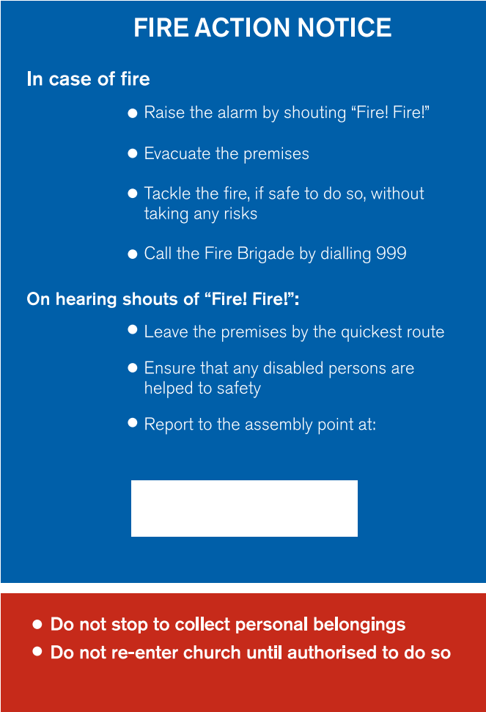

Next steps
Once you have completed this checklist and taken any steps needed to mitigate any risks, please make sure that a copy is kept in an accessible location. Please remember you should regularly review your Fire Risk Assessment.
It is recommended that you include fire safety as a regular item in the agenda for your PCC meetings.

