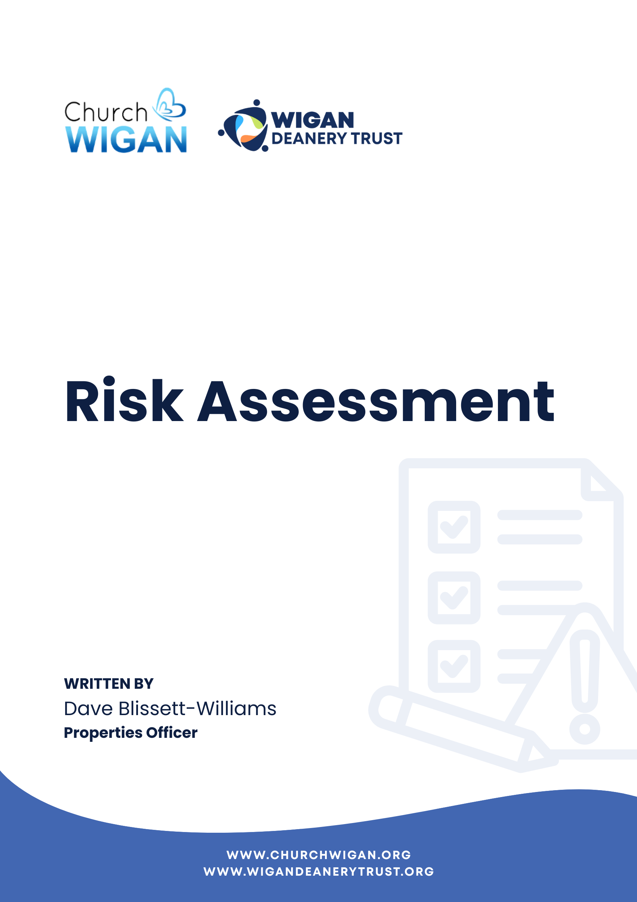

Risk Assessment
Organisation: Church Wigan
Location:
Created By: David Blissett-Williams
RA Name: Church Services
RA Created On: April 2026
Activity / Procedure / Area Being Assessed
Church Services
Overview
This risk assessment must be reviewed and updated to ensure that all controls have been implemented. Where necessary, it must be amended to ensure it reflects the nature of your operation. Risk ratings given on the risk matrix reflect the assessment of the highest possible risk before any action is taken and after any actions have been taken to reduce or eliminate the overall risk.
Risk Analysis with No Action Taken
Based on operations, industry statistics and guidance, the overall risk rating for this risk assessment before any action is taken:
Impact
Medium | High | High
Low | Medium | High
Low | Low | Medium
Probability
An injury requiring further medical assistance e.g. Paramedic or Hospital. Possible that the event will happen.

Risk Analysis with Action Taken
Following the successful review and implementation of actions set out in this risk assessment document, the overall risk rating for this risk assessment is:
Impact
Medium | High | High
Low | Medium | High
Low | Low | Medium
Probability
Minor injury requiring first aid e.g. Cuts and Grazes. Possible that the event will happen.
What are the hazards?
- Persons entering and leaving the site
- Walking through Site including Graveyards
- Use of walkways - obstructions
- Access to balcony areas e.g. walking /standing by
- Use of Children’s areas
- Trailing cables
- Wet floors
Who might be harmed?
Volunteers/Employees, Contractors, • Congregation (including elderly and children).
How might they be harmed?
Trapping in the doors
Slips on ice outside the doors in Winter or where stone flags have moss or algae
Slips on wet floors at entrances due to inclement weather conditions
Walking on defective flooring causing trip or fall
Slips on spillages
Trips and collisions
Tripping hazards
Walking or climbing on graves/tombs
Electric shock
Falls
Trailing cables/tripping hazards
Manual Handling of audio-visual equipment
Workplace Transport Accidents in Car Parks
Inability to evacuate due to overcrowding/occupancy levels
What are we doing already? (Action we are taking)
Doors must be checked daily to ensure they efficiently to ensure the opening/closing mechanism will not trap users e.g. finger traps etc.
Each site to ensure a procedure is in place for gritting the site entrances. This procedure to be in writing and attached to this risk assessment.
At doorways where wet weather may become an issue suitable and sufficient water retention matting must be provided.
Church Wardens must be aware to put out ‘Caution – Wet Floor Signs. These must be removed when the risk does not exist anymore i.e. floor dry.
Cleaners are aware of their duties and monitor regularly.
Ensure site staff and contracted staff e.g. cleaners are instructed on how to report any defects immediately they are noticed. Floors must be checked daily.
Staff and contractors must report all spillages immediately.
Where necessary, the area should be cordoned off until the spillage is removed
It is recommended that no fixtures should be placed within 2.5m of access/exit to stairs.
Signage must be located so as to not cause any tripping hazard or obstruction.
Seating, planters etc must be situated so as to not cause any trip hazard or obstruction and must not interfere with any fire exits. Trailing cables must not cause additional trip hazards.
Balustrades are provided, (new) which must be at least 950mm high (910mm in existing), and must comply with the relevant British Standards. These must be regularly checked for any damage. All glass must be safety glass.
All signage should be checked as part of the daily checklist to ensure it is secure. The Health and Safety (Safety Signs and Signals) Regulations 1996
Any high-level displays must be properly secured and must be supported by the relevant paperwork in terms of loadings etc.
Arrangements must be in place for regular examinations of Children’s areas, particularly in relation to electrics. Sockets must be RCD protected
Graveyards should be checked regularly for any damage to graves, tombs and reported to the Church Warden immediately.
Adequate lighting throughout the premises.
Secure or tape down cables.
Fire risk assessment in place.
Clearly marked fire exits and kept unobstructed.
Fire extinguishers maintained and accessible.
Trained fire wardens/stewards.
Safe candle use (supervised, stable holders).
Portable Appliance Testing of electrical equipment and 3 – 5 yearly Electrical Installation Testing.
Monitor attendance vs capacity.
Stewards to guide seating and exits.
Keep aisles and exits clear.
Emergency evacuation plan communicated to staff/volunteers.
Safeguarding policy in place.
DBS-checked volunteers where required.
Supervision ratios maintained.
Fire evacuation point.
Emergency contacts displayed.
First aid kit available.
Trained first aider on site (if possible).
Incident reporting procedure in place.
Review Record
Name: Dave Blissett-Williams
Reviewed Date:
End of Report

